**Serious game development for dementia care using preferred music, music therapy**

**LW Fourie**

**31607500**

Research methodology for the research project submitted in *partial* fulfilment of the requirements for the degree BSc Hons 2023 in Computer Science and information systems in Potchefstroom at the North-West University

Supervisor: Prof. Gunther Drevin

Date of submission: 16-5-2023

Version: 1

Table of contents

1 Introduction 1

2 Paradigms 1

3 Research Methodology 2

4 Research Methods 4

5 Research Design 5

6 Conclusion 6

7 References 7

List of Tables

**No table of figures entries was found.**

List of Figures

Figure 1: Framework for design science (Wieringa, 2014) 3

Figure 2: Gantt chart for project timeline 5

# Introduction

This study will focus on music therapy as a serious game for dementia care by using preferred music. This means incorporating a patient’s own music preferences into music therapy, thus allowing them to enjoy the therapy more as well as allow them to be more accepting of the intervention. This chapter contains the methods used in the design of the study as well as the serious game to be developed alongside the study. How information will be gathered and how this information will be used and incorporated into the project.

This chapter will explain the paradigms, methodology as well as methods and design of the research used by the study. This is to better explain how the study will be completed as well as how it can be replicated. Explaining all reasoning behind certain choices made as well as the overall direction and aim of the study.

Further in this chapter, the paradigms will be discussed, how they are used and how it will affect the study. The Methodology of the study, and how it will be used for not only the study but the design of the serious game as well as the controller for the game. The research methods will also be discussed as well as the steps that will be followed in accordance with the paradigms and methodology chosen. A research design will also be discussed with a more in-depth view of the study itself.

# Paradigms

**Positivism:**

The goal of positivism is to confirm previous hypotheses and experiments, with the goal of advancing science even further using the findings from hypothesis testing. Studies that adopt positivism as their paradigmatic approach frequently use quantitative methods to identify associations or relationships. Generalizing inferences, replicating findings, and using controlled experiments to gather data have all been guiding principles in positivist science. Research must be evaluated for quality before being added into the study. (Park, 2020)

**Constructivism:**

By creating meaning from the experience and viewpoints of the participants, constructivism is a method of comprehending things. Constructivism is a paradigm that places more emphasis on the use of participants and is therefore more suited to qualitative research methods. To comprehend users' experiences, this is accomplished by utilizing various data gathering tools. (Adom, 2016)

**Interpretivism:**

For the purpose of understanding social interactions, interpretivism employs qualitative research techniques that place an emphasis on people's views, motivations, and reasoning rather than on qualitative facts. This indicates that interpretivism makes the assumption that language, consciousness, shared meanings, and other social constructs are necessary for gaining access to reality. (Nickerson, 2023)

**Pragmatism:**

Pragmatism is the emphasis on what actually works as opposed to what might be seen as true or real. According to this theory, the only way to evaluate truth is by its effects. Practicality, problem-solving, and the application of several methodologies are highlighted by a pragmatic paradigm. (Weaver, 2018)

# Research Methodology

The research methodology that will be followed is the design science approach to accommodate the development of a serious game as well as a controller along with it. Using a design science approach allows the identification of a problem and then the development and design of a solution. Evaluating the solution and its effectiveness allows for adjustments to be made before it is implemented. Using expert reviewers allows the project to be reliable as well as ensures that it is developed with the correct considerations. Finally reflecting on the project will allow for the ability to identify areas for improvement as well as any limitations in the design of the project.

Using research as a backbone for every aspect of the artefact will ensure the validity of the project. Designing the serious game, preferred music script, and controller in accordance with the findings of previous studies will allow for the best outcome possible.

Studies used as a reference will be evaluated based on the design of the study, the date of the study, and the credibility of the researchers that conducted the study. This is to ensure that no studies that would be detrimental to the project outcomes will be included. Studies will be found through different search techniques and using keywords such as “Serious games”, “Dementia care”, “Music therapy”, and “Preferred music” as well as different combinations of these keywords.

The framework used for design science as a methodology is displayed in figure 1. Although this is a predesigned framework, it will be adjusted to fit the context of the project.

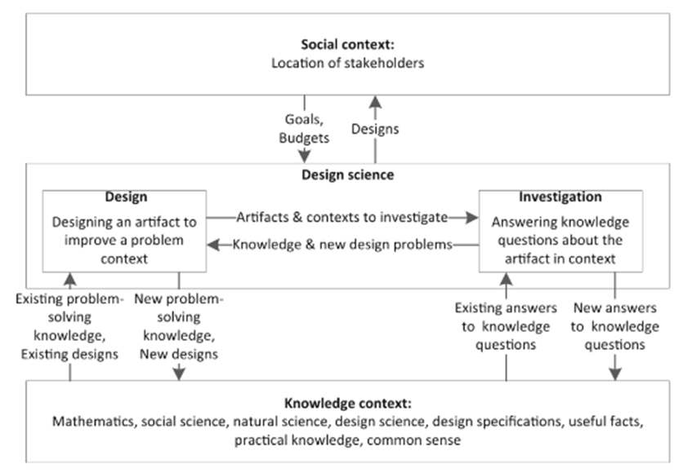

Figure : Framework for design science (Wieringa, 2014)

In this framework design science is explained for a system that is sponsored by stakeholders and not the design of a project for a study, thus the appropriate adjustments will be made.

**Social context:**

These are all the stakeholders that are influenced by the project and study, this will include anyone who is affected by the content or affects the content, as well as the outcome of the study. This can include possible users, maintainers, instructors and more. This would also include the sponsors of the project, those who determine the direction of the project as well as provide the funds for the project.

**Knowledge context:**

The knowledge context is the existing theories from science and engineering, thus it includes currently existing designs, useful facts and information on existing and available products, as well as lessons learned from the experience of researches and experts in the field of the study.

**Investigation:**

This is to go through existing knowledge and adding to it with the knowledge gained through the study. Determining a question and finding the answers through prior knowledge in an effort to improve the outcome of the project.

**Design:**

Taking the knowledge that has been gather and putting it to practical use in the development of the project. Using the information that is deemed useful and discarding the information that is deemed unnecessary to ensure the reliability of the outcome of the project.

Investigation and design are what form the core of design science in accordance with the framework that is used, while knowledge is just a tool used to reach the outcome of the project and solve the problem that is identified.

# Research Methods

The use of music therapy in a serious game for dementia has been done but none have incorporated preferred music into the game. Using preferred music is more stimulating to patients and incorporating it into a serious game will also help caretakers.

Through analysing the results gathered by previous studies as a reference to the development of the artefact a positivism paradigmatic approach will be taken. This means the results studies have gathered through observation, experimentation and statistical analysis will determine the direction of the project. This means that only content analysis will be used as a method of gathering data for the study as it will give the best result by using the results of previous studies.

Surveys and observation would not be an effective way of gathering data due to ethical constraints as well as taking into consideration that the artefact will only serve as a proof of concept. These ethical constraints include getting permission to work with patients and use their information as well as test the project on patients and gather their data for the study, due to time constraints this will not be feasible.

Gathering data on every aspect of the development of the artefact is crucial to the success of the final project. To do this a lot of studies will be needed in the development of serious games for dementia care as this is a sensitive field. Due to the sensitivity of patient information, no direct information on patients will be used in the study, even when gathering information from experts only their experience in working with patients will be used.

A timeline of the project life cycle, which is set to end on 30/10/2023, as well as important dates will be discussed in the next section of this chapter.

# Research Design

As identified in the previous section, only content analysis will be used for gathering information for the design of the project. This is further supported by the methodology framework that is chosen.

In the social context the only stakeholders that are influenced are patients that decide to use the program after the development lifecycle has ended as no patient information will be used during the development of the project on in the study itself.

Investigation will be the focus for data gathering by going through existing studies as well any other knowledge context that are deemed useful for the study. This will include expert opinions of medical experts for the study as well as the opinions of expert reviewers that will test the game. Using these sources of information will ensure the validity and reliability of the study as well as the game to be developed.

Designing the game and the remote will be done by using the information gathered as a blueprint for the project. Thus any findings of existing studies as well as results of previous products will be used as well as be improved through the development and design of this project this is to ensure no unnecessary or personal opinions are used in the design of the project.

To ensure that everything is completed on time as well as diligently as possible, a timeline will be followed with due dates set in place. This is displayed in the Gantt chart in in figure 2:

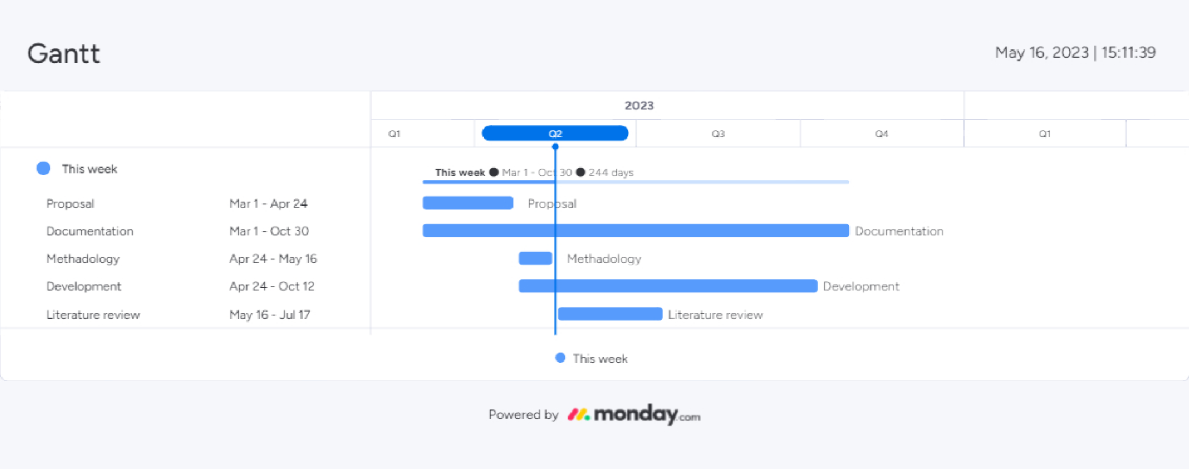

Figure : Gantt chart for project timeline

As can be seen, the project is already in progress, and adjustments will be made all the way through the project's lifecycle, as work will continue.

# Conclusion

In conclusion, this chapter has provided an overview of the research methodology used as well as the paradigm employed in the study. An overview of different paradigms, namely positivism, constructivism, interpretivism, and pragmatism, were discussed and the most appropriate paradigmatic approach for the study was identified through reviewing the constraints as well as the aim of the study. The research methodology adopted for this study is a design science approach, which involves problem identification, solution development, evaluation, and reflection.

Through the design science approach, a serious game can be developed as well as a controller for the game by incorporating expert reviewers’ input and making changes and corrections accordingly. Through using the results of previous studies, the projects’ validity and reliability can be ensured. The serious game as well as the controller will also be developed with the results of previous studies as a guideline.

The identification of relevant studies will be done through the use of various search techniques. These studies will then be further evaluated using predetermined criteria to ensure the credibility of the study, thus also only including studies that align with the project’s objectives.

This chapter outlines the research methodology, paradigms, methods used, as well as the design of the project. Emphasis is put on the design science approach as well as an in-depth discussion on how it will be incorporated into the study. The research design section discussed the focus on content analysis through the use of positivism as well as determining the timeline of the project.

# References

Park, Y.S., Konge, L. & Artino, A.R. 2020. The positivism paradigm of research. *Academic Medicine*, 95(5):690-694*.*

*Adom, D., Yeboah, A., & Ankrah, A.K. (2016). Constructivism Philosophical Paradigm: Implication for Research, Teaching and Learning. Global Journal of Arts Humanities and Social Sciences, 4(10), 1-9. ISSN: 2052-6350 (Print), 2052-6369 (Online)*

*Nickerson, C. (2023) Interpretivism Paradigm &amp; Research Philosophy, Simply Sociology. Available at: https://simplysociology.com/interpretivism-paradigm.html (Accessed: 10 May 2023).*

*Weaver, K. ed., 2018. The SAGE Encyclopedia of Educational Research, Measurement, and Evaluation. Vol. 4. Thousand Oaks,, CA: SAGE Publications, Inc. Available at:* [*https://doi.org/10.4135/9781506326139*](https://doi.org/10.4135/9781506326139)

*Wieringa, R.J. 2014. Design science methodology for information systems and software engineering. Springer*